**Họ Và Tên: Huỳnh Kim Phát**

**Mã Số Sinh Viên: 19521992**

**Môn: Phát triển ứng dụng web**

**Bài: Lab2**

**W3School**

**Bài 1:**



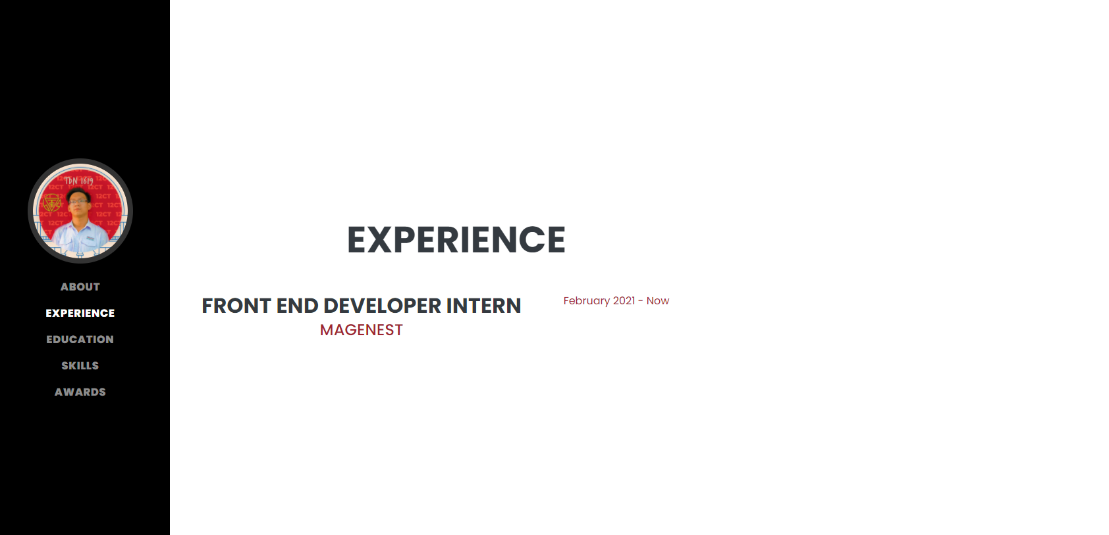

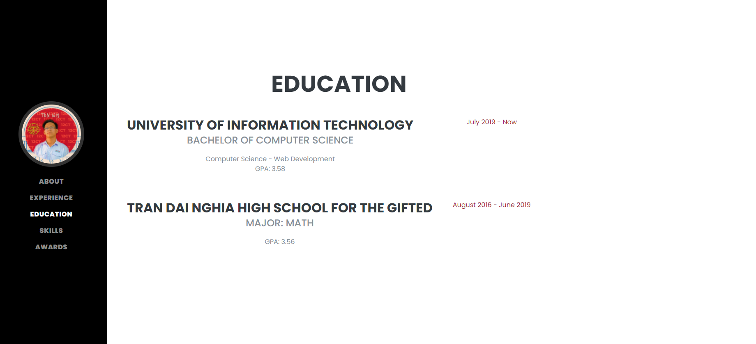





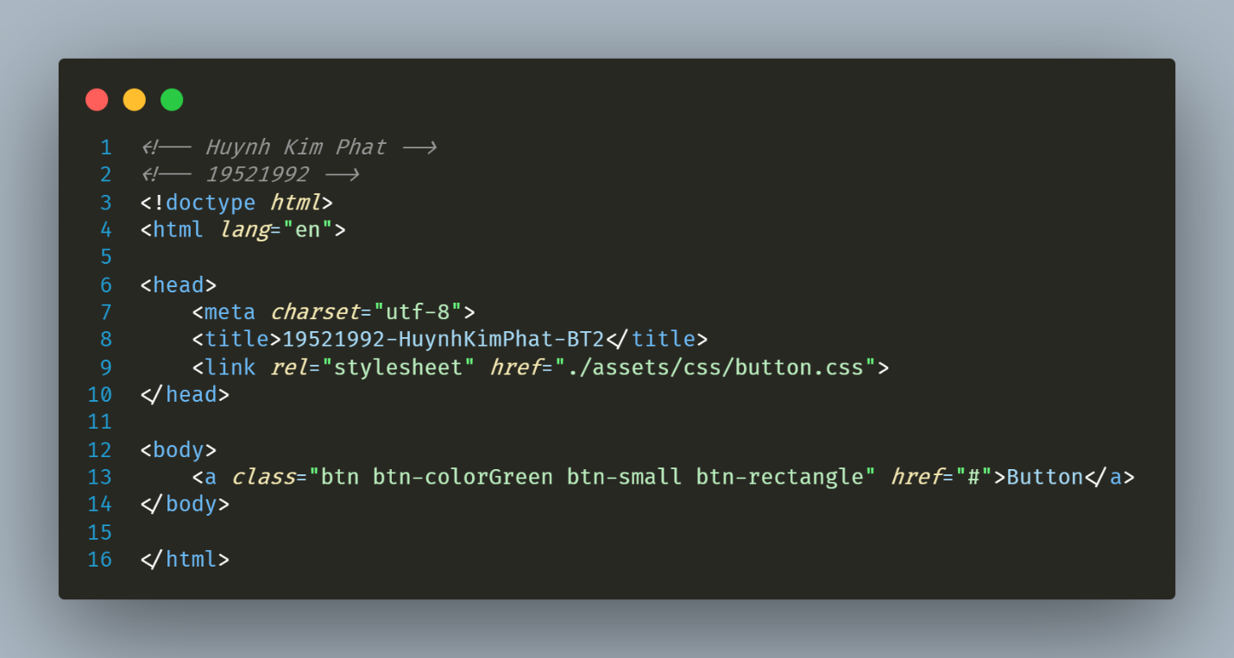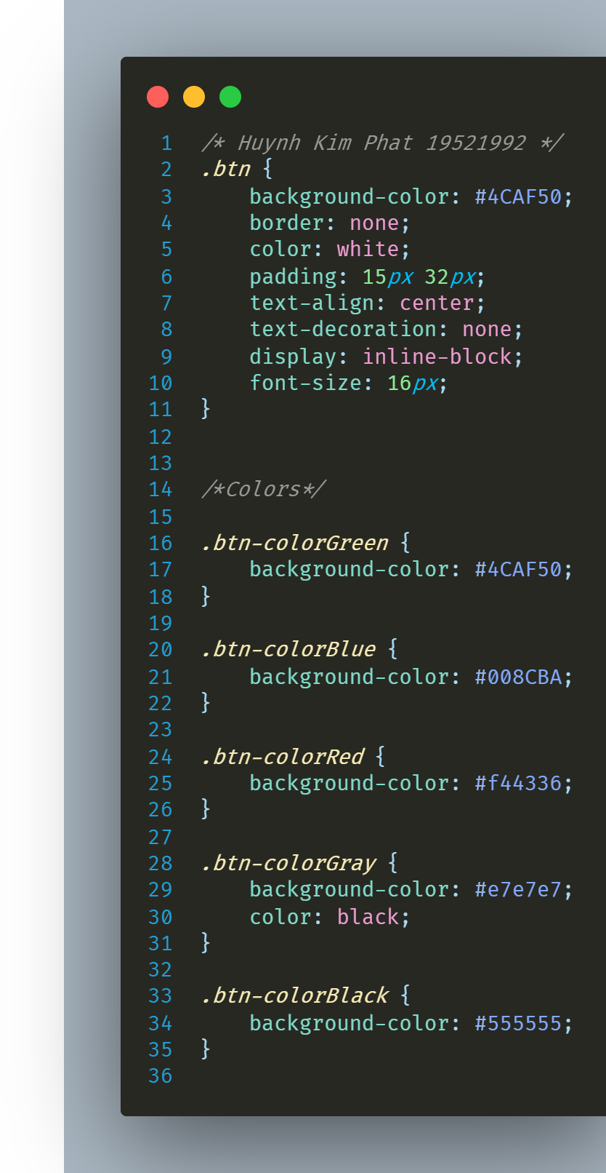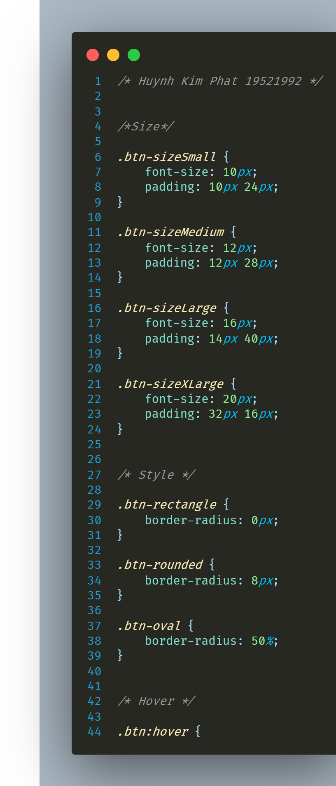

**Bài 3:**



**Bài 4:**

